Hướng dẫn tạo project React + JavaScript + BootStrap

1. Khởi tạo project với Vite
npm create vite@latest se1949-se0000-m2 -- --template react

2. Cài đặt BootStrap
npm install react-bootstrap bootstrap

4. Import BootStrap CSS
Mở file src/index.css và thay toàn bộ nội dung bằng:
@import 'bootstrap/dist/css/bootstrap.css';

5. Hiển thị BootStrap CSS
Mở src/App.jsx và thử dùng BootStrap
function App() {
return (
<>
<Container className="mt-5">
<Alert variant="success">
🎉 Chúc mừng! Bạn đã tích hợp thành công Bootstrap vào React.
</Alert>
<Alert variant="success">Đây là thông báo thành công!</Alert>
<Alert variant="danger">Đã có lỗi xảy ra, vui lòng thử lại.</Alert>
<Alert variant="warning">Cảnh báo: Pin yếu!</Alert>
<Alert variant="info">Thông tin: Hệ thống sẽ bảo trì vào 12h đêm.</Alert>
<Button variant="primary" onClick={() => setCount((count) => count + 1)}>Click thử xem!</Button>
<Dropdown>
<Dropdown.Toggle variant="success" id="dropdown-basic">
Chọn hành động
</Dropdown.Toggle>
<Dropdown.Menu>
<Dropdown.Item href="#/action-1">Chỉnh sửa</Dropdown.Item>
<Dropdown.Item href="#/action-2">Cài đặt</Dropdown.Item>
<Dropdown.Divider />
<Dropdown.Item href="#/action-3" className="text-danger">
Xóa tài khoản
</Dropdown.Item>
</Dropdown.Menu>
</Dropdown>
</Container>

</>
)
}

export default App

6. Chạy project
npm run dev

7. Kết quả
8. Những Component cần quan tâm :
- Table/Grid/Form
<Form>
<Form.Group as={Row} className="mb-3">
<Form.Label column sm="4">
Email
</Form.Label>
<Col sm="8">
<Form.Control type="text" value={email} onChange={(e) => setEmail(e.target.value)} />
</Col>
</Form.Group>
<Form.Group as={Row} className="mb-3">
<Form.Label column sm="2">
Password
</Form.Label>
<Col sm="10">
<Form.Control type="password" placeholder="Password" />
</Col>
</Form.Group>
</Form>
- Label
- TextBox
- Password
- Radio Button (name trùng nhau hết và chỉ khác giá trị/ Chỉ chọn được 1 thôi
- CheckBox ( Được chọn nhiều)
- DropList/Selection
- Button
- Link
- Modal Popup
- TextArea

return (
<div style={{ minHeight: '100vh', backgroundColor: '#f8f9fa' }}>
{/* Header */}
<Navbar bg="light" className="border-bottom">
<Container fluid>
<Navbar.Brand>
<strong>Logo</strong>
</Navbar.Brand>
<Navbar.Text className="mx-auto">
<h4 className="mb-0">Inventory Management</h4>
</Navbar.Text>
<Navbar.Text>
<strong>Date: yyyy-MM-dd</strong>
</Navbar.Text>
</Container>
</Navbar>
{/* Main Content */}
<Container className="mt-4">
<div className="bg-white p-4 border rounded">
<h3 className="mb-4">Add New Ingredient</h3>
<Form>
{/* Ingredient Name */}
<Form.Group as={Row} className="mb-3">
<Form.Label column sm={2} className="text-end">
<strong>Ingredient name:</strong>
</Form.Label>
<Col sm={10}>
<Form.Control type="text" />
</Col>
</Form.Group>
{/* Price Range */}
<Form.Group as={Row} className="mb-3">
<Form.Label column sm={3} className="text-end">
<strong>Price from (đ):</strong>
</Form.Label>
<Col sm={3}>
<Form.Control type="number" />
</Col>
<Col sm={1} className="text-center">
<strong>To:</strong>
</Col>
<Col sm={3}>
<Form.Control type="number" />
</Col>
</Form.Group>
{/* Supplier */}
<Form.Group as={Row} className="mb-3">
<Form.Label column sm={3} className="text-end">
<strong>Supplier:</strong>
</Form.Label>
<Col sm={9}>
<Form.Control type="text" />
</Col>
</Form.Group>
{/* Producer Name */}
<Form.Group as={Row} className="mb-3">
<Form.Label column sm={3} className="text-end">
<strong>Producer name:</strong>
</Form.Label>
<Col sm={9}>
<Form.Control type="text" />
</Col>
</Form.Group>
{/* Category and Entry Date */}
<Form.Group as={Row} className="mb-4">
<Form.Label column sm={3} className="text-end">
<strong>Category:</strong>
</Form.Label>
<Col sm={3}>
<Form.Select>
<option value="">Select category</option>
<option value="vegetables">Vegetables</option>
<option value="fruits">Fruits</option>
<option value="meat">Meat</option>
<option value="dairy">Dairy</option>
<option value="spices">Spices</option>
</Form.Select>
</Col>
<Col sm={1}></Col>
<Form.Label column sm={2} className="text-end">
<strong>Entry Date (yyyy-MM-dd):</strong>
</Form.Label>
<Col sm={3}>
<Form.Control type="date" />
</Col>
</Form.Group>
{/* Buttons */}
<Row className="mt-4">
<Col className="text-center">
<Button variant="primary" size="lg" className="me-3 px-5">
Save
</Button>
<Button variant="secondary" size="lg" className="px-5">
Back
</Button>
</Col>
</Row>
</Form>
</div>
</Container>
{/* Footer */}
<div className="fixed-bottom bg-light border-top p-3">
<Container>
<p className="mb-0">@2026 FPT University</p>
</Container>
</div>
</div>
);

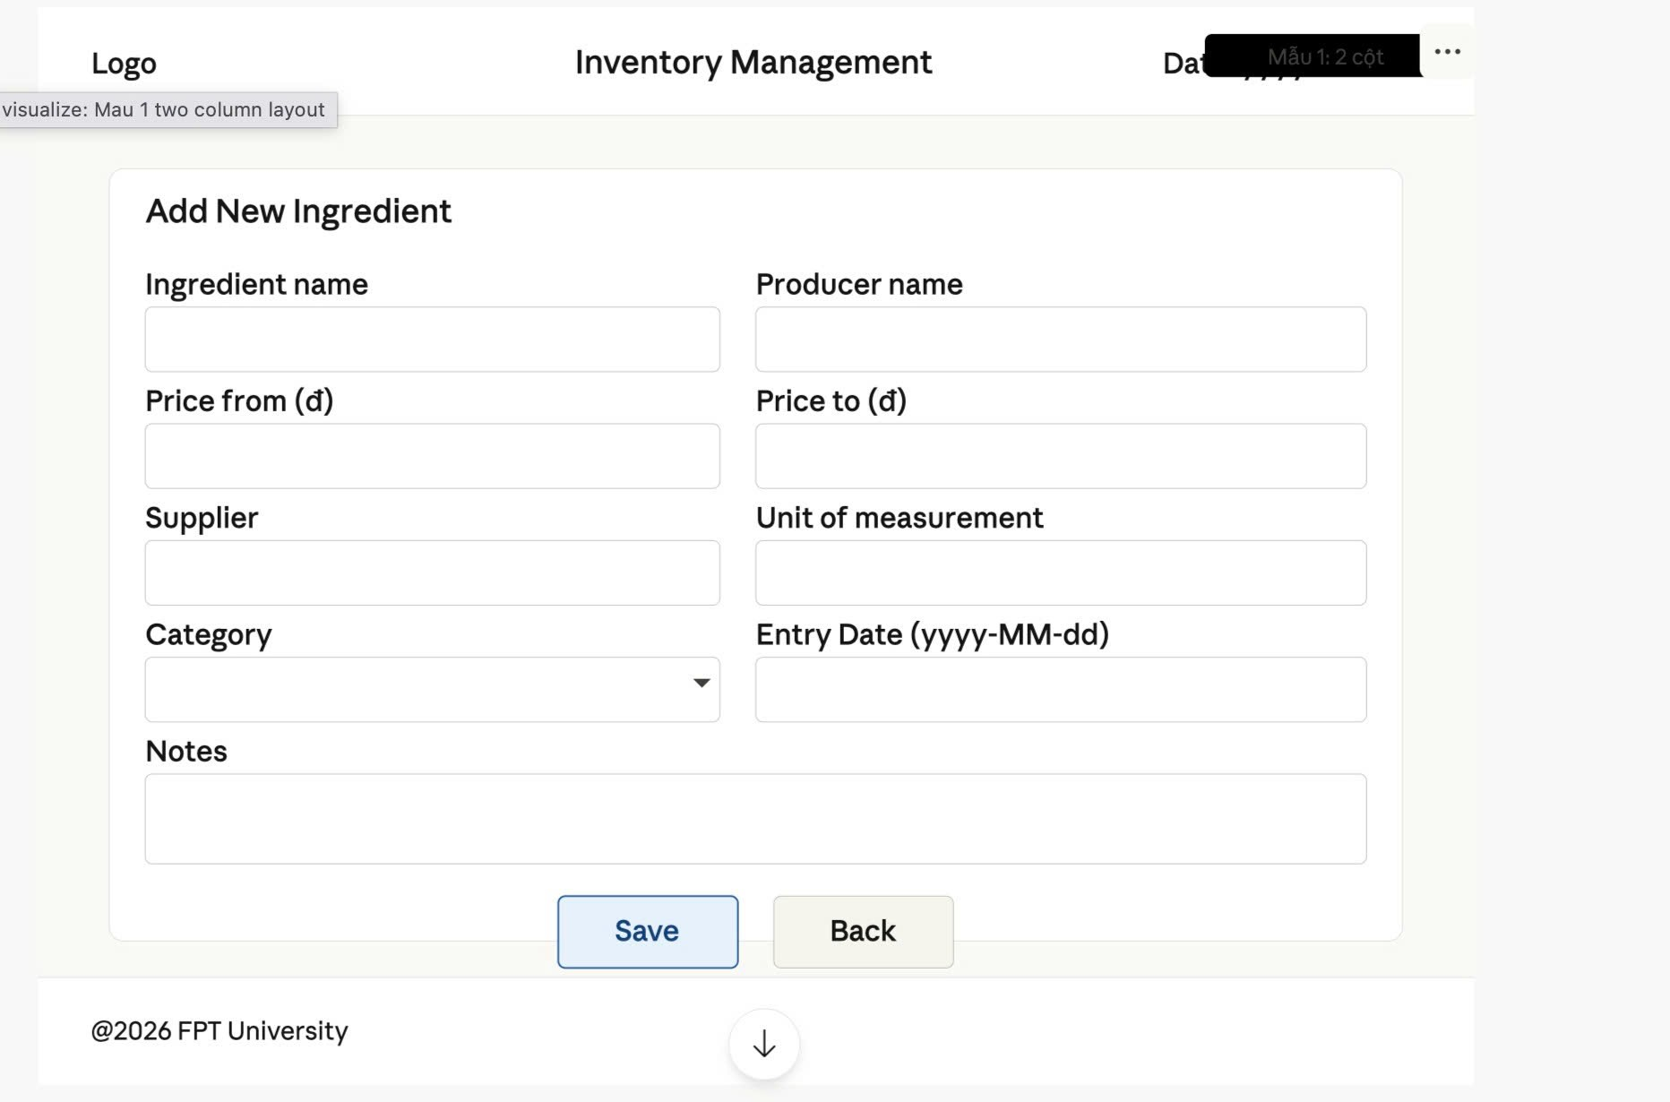

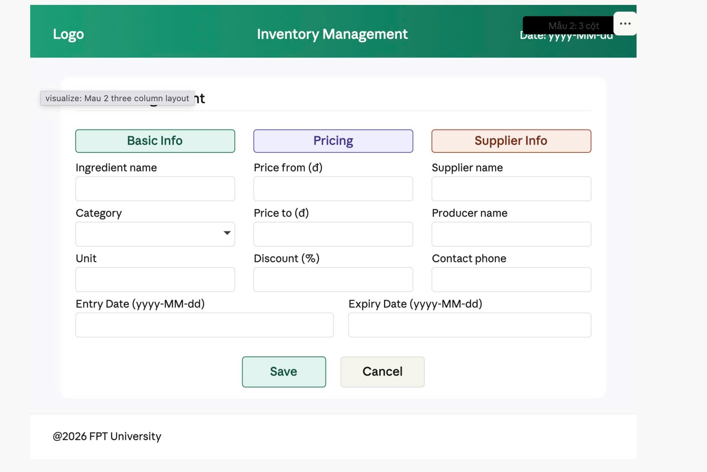
Bài 02 : Tạo cấu trúc dự án có front-end

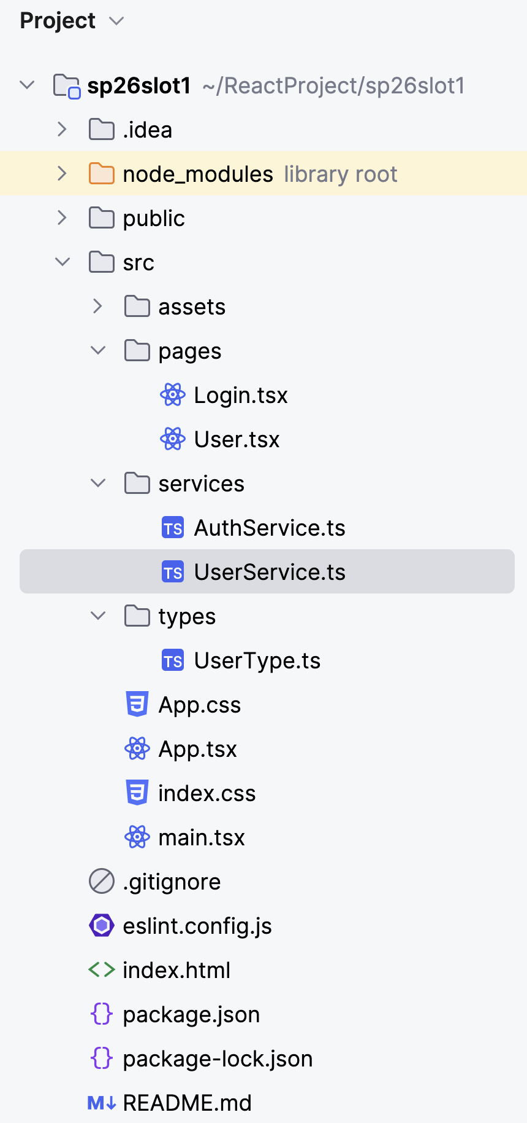

Bài 03 : Tạo Link Route trong
1. Tạo Route
npm install react-router-dom
2. Tạo link ở main.tsx
import { StrictMode } from 'react'
import { createRoot } from 'react-dom/client'
import { BrowserRouter, Routes, Route } from 'react-router-dom'
import './index.css'
import App from './App.tsx'
import Login from './pages/Login.tsx'
createRoot(document.getElementById('root')!).render(
<StrictMode>
<BrowserRouter>
<Routes>
<Route path="/" element={<App />} />
<Route path="/login" element={<Login />} />
</Routes>
</BrowserRouter>
</StrictMode>,
)
3. Gán link ở trang ReactJS
import { Link } from 'react-router-dom'
<Link to="/login" className="text-blue-600 hover:underline font-medium mt-4 inline-block">
Đăng nhập
</Link>

4. Hướng dẫn tích hợp API
npm install axios
Call API
import { useState } from "react";
import axios from "axios";
import { useNavigate } from "react-router-dom";
export default function Login() {
const [email, setEmail] = useState<string>("");
const [password, setPassword] = useState<string>("");
const [error, setError] = useState<string>("");
const [loading, setLoading] = useState<boolean>(false);
const navigate = useNavigate();
const handleLogin = async (): Promise<void> => {
setError("");
setLoading(true);
try {
const response = await axios.post("/api/v1/auth/login", {
email,
password,
});
localStorage.setItem("token", response.data.token);
navigate("/products");
} catch (err) {
if (axios.isAxiosError(err) && err.response) {
setError(err.response.data.message || "Email hoặc mật khẩu không đúng");
} else {
setError("Không thể kết nối đến server");
}
} finally {
setLoading(false);
}
};

Tách tầng Service
1. Tạo thư viện API chung: src/services/api.js
import axios from 'axios';
const api = axios.create({
baseURL: import.meta.env.VITE_API_BASE_URL || 'http://localhost:8080/api'
});
export const get = (endpoint) => api.get(endpoint);
export const post = (endpoint, data) => api.post(endpoint, data);
export const put = (endpoint, data) => api.put(endpoint, data);
export const remove = (endpoint) => api.delete(endpoint);

===================
const [lists, setLists] = useState([]);
useEffect(() => {
const categoryList = async () => {
try {
const respone = await get("/categories");
setLists(respone.data);
} catch (error) {
console.error("Error", error);
}
};
categoryList();
}, []);

2. Sử dụng trong Login.tsx

import {authenService} from '../services/AuthenService';

const handleLogin = () => {
authenService.login(email, password).then((response) => {
localStorage.setItem("token", . response.data.accessToken);
navigate("/app");
}).catch((err) => {
console.error(err);
});
}

3. Lấy dữ liệu sử dụng jwt

const navigator = useNavigate();
const [users, setUsers] = useState([]);
const userlist = async () => {
const token = localStorage.getItem("token");
if (!token) {
console.error("No token found");
navigator("/");
return;
}
try {
const respone = await axios.get("http://localhost:8080/api/v1/users?page=1&size=5", {
headers: {
Authorization: `Bearer ${token}`,
}
})
.then((response) => {
console.log("ABC", response);
setUsers(response.data.data.content);
})
.catch((error) => {
console.error(error);
});
}catch (error) {
console.error("Error fetching user list:", error);
}
};
useEffect(() => {
userlist();
},[])

return (
<>
<div>
<h1>User</h1>
<table className="user-table">
<thead>
<tr>
<th>ID</th>
<th>Name</th>
<th>Email</th>
</tr>
</thead>
<tbody>
{users.map((user: any) => (
<tr key={user.id}>
<td>{user.id}</td>
<td>{user.email}</td>
<td>{user.fullName}</td>
</tr>
))}
</tbody>
</table>
<button type="button">Hello</button>
</div>
</>
);
}
export default User;

Cấu hình URL bên ngoài
tạo .env :

VITE_API_URL=http://localhost:8080

Cấu hình API ở Services:
const login = async (email: string, password: string) => {
const data = await axios.post(`${import.meta.env.VITE_API_URL}/api/v1/auth/login`, {
email,
password,
});
return data;
};

